**Electro-Assis Validation Testing**

The following data was tested in each of the three separate entry windows. Since the results are floating points with two decimals, some of the testing data included two decimal places.

One of the calculations was incorrect which was repaired. [I don’t remember which one it was]

The result of the following code should be an error.

Abcefg

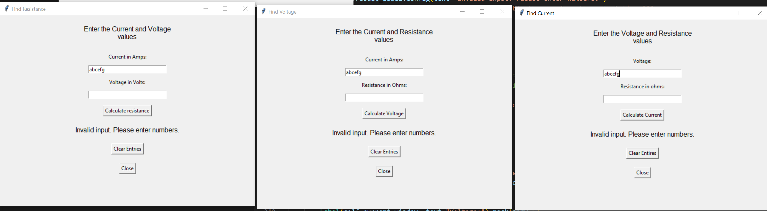

Entering a negative number should also produce an error, below.

-5,2

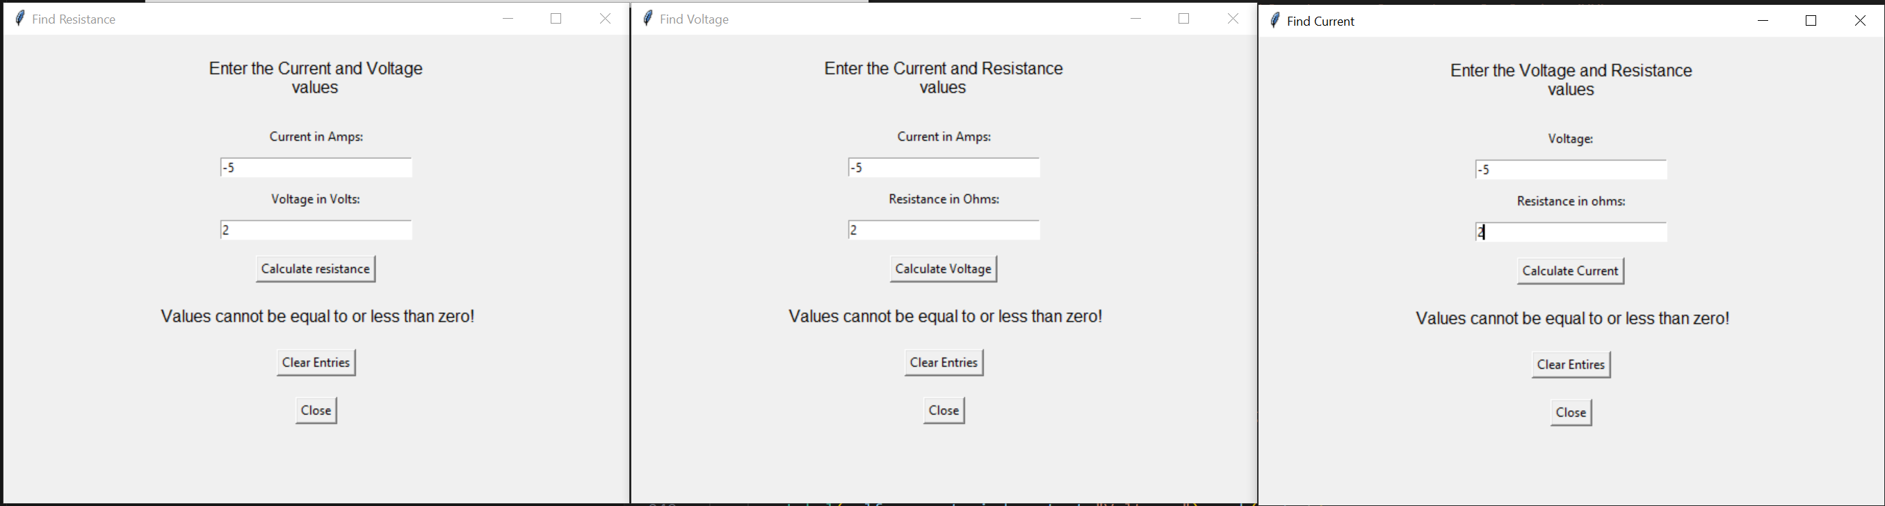

Below: proper data entries including the results which indicate calculation errors if wrong.

**Find Resistance:**

1 Amp, 100 Volts = 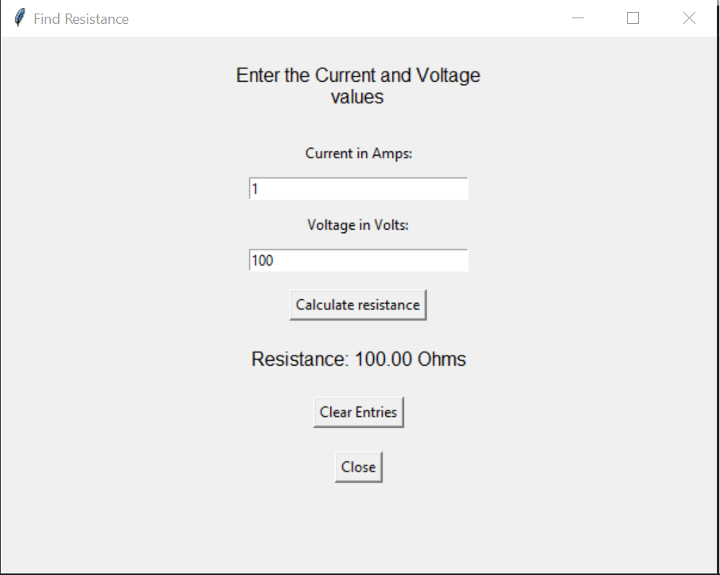 100 Ohms is correct.

123.23 Amps, 168.56 Volts = 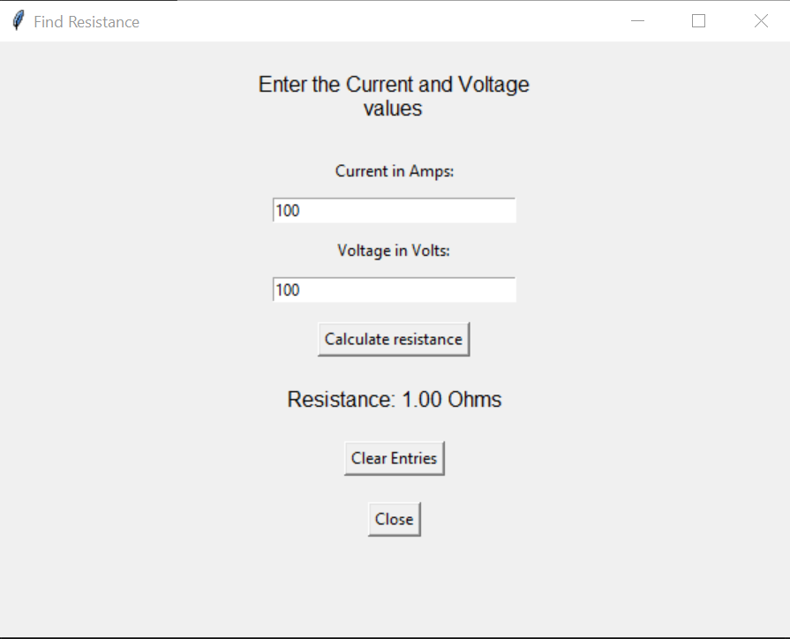1.37 Ohms is correct.

**Find Voltage:**

500 Ohms, 1 Amp = 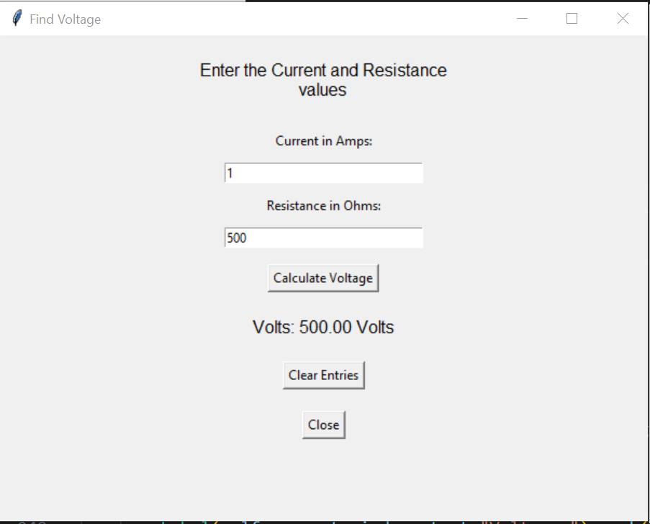500 Volts is correct.

1093.56 Ohms, 3.78 Amps=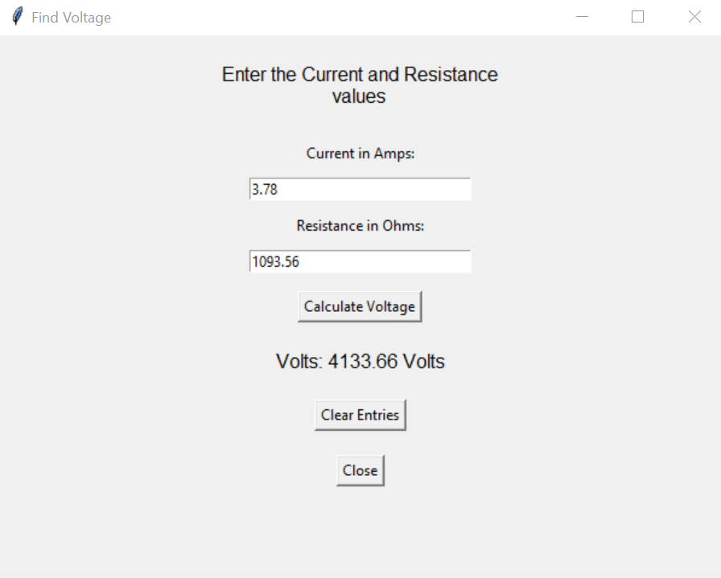4133.66 volts is correct.

**Find Current:**

125.35 volts, 1023.59 Ohms = 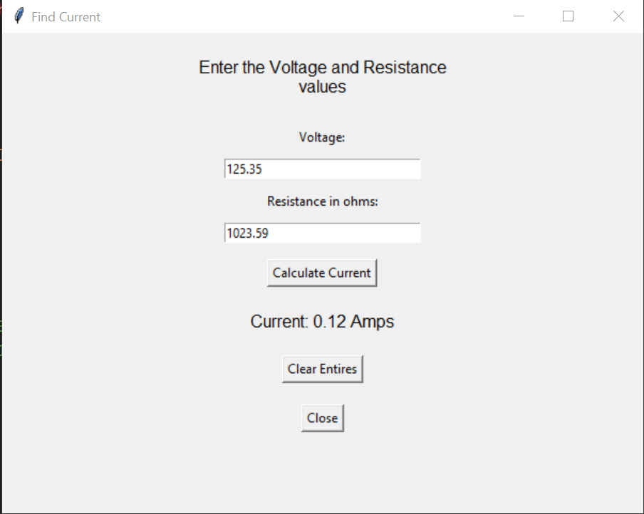0.12 Amps is correct.

15103 volts, 41.67 Ohms = 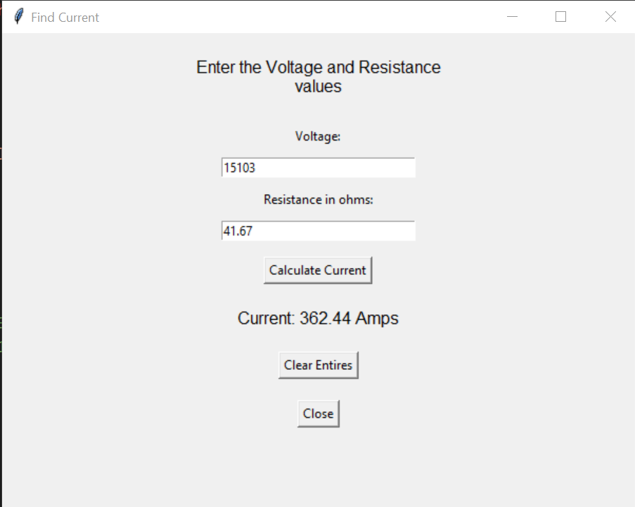362.44 Amps is correct.